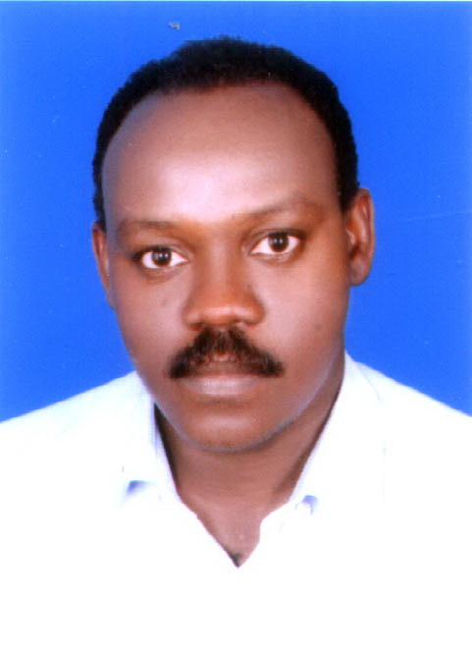
CURRICULUM VITAE
Personal Data:
Family name: Mohammed
First name: Ahmed
Middle name: Zakaria
Date of birth: 1/1/1975
Place of birth: Umm Ruwaba
Nationality: Sudanese
Marital status: Married
Languages: Arabic (mother tongue) and English (fluent)
Mailing address:
Address: Al-Baha University – Saudi Arabia
Physics department
Tel: +966502245933
Email:dr.zakaria11@gmail.com, amjadalaa11@gmail.com,
azakaria11@bu.edu.sa,
Khartoum – Sudan
Private Tel: +249-963916100
Educational History:
Higher diploma in Physics from Sudan University for Science and Technology
PhD. degree awarded on 15/3/2015 ⇒ Sudan University for Science and Technology.
June. 2012 – March. 2015: working on PhD. degree (Thesis on: Expression of Energy and Lasing in Generalized Special Relativity). Department of physics Sudan University for Science and Technology (Sudan)
June. 2007- Nov. 2009: working on M.Sc. Sudan University for Science and Technology
June 1995 – May 1999 B.Sc. student (physics) Sudan University for Science and Technology.

Employment History
March. 2016 till now Assistant professor. AL-Baha University
March 2015 – 2016 University of the Holy Quran and Islamic Sciences
Aug. 2001 -20012 Qunfudha University College.

Teaching experience in physics:
Have teaches undergraduate courses: Quantum Mechanics I Classical Mechanics, I&II Electrodynamics, Thermodynamic, Statistical Mechanics, computational Physics, Quantum Mechanics II, Electromagnetism
Research experiences
PhD. degree awarded on 15/3/2015 ⇒ Sudan University for Science and Technology M.Sc. postgraduate research student Sudan University for Science and Technology 2007–2009
Publications:
(1) “Theory of polarized neutron form factors of cerium monopnictide CeP”,
K. Ayuel, Amani Salah, Ahmed Zakaria, Physica B, 552 (2019) 236.
doi: 10.1016/j.physb.2018.10.013
(2) “Orbital and spin contributions to magnetic hyperfine fields of the 3d transition metal ions”, K. Ayuel, Ahmed Zakaria, JMMM 457 (2018) 42.
doi: 10.1016/j.jmmm.2018.02.044
(3)”Theoretical investigations of optical properties of FeF2”, Karol Kuacgor, Ahmed Mohammed, and Emmanuel Longa, accepted for publication in Journal of the Optical Society of America A (2021),
doi: 10.1364/JOSAA.425795.
Other experiences
Considerable knowledge of Dos, Ubuntu.
Considerable knowledge of some computer algebra programs (Maple)
Considerable knowledge of computational physics.
Little experience in writing programs using C++.
Quantum espresso
Conferences:
Referees:

Prof. Dr. Karlo Ayuel
"E-mail: karloayuel@gmail.coml"
Address: Department of Physics,
Tel: +966599328857
AL-Baha University, Saudi Arabia
Prof. Dr. Mubarak Dirar
"E-mail: mubarakdirar@sustech.edu"
Address: Sudan University for Science and
Technology,
Tel: +249122072454.
Khartoum – Sudan.

